Software Engineering
Software Requirements Specification
(SRS) Document

Health First Deakin

30th/Dec/2022

Team Members:

ALI ADIL ABDULRAZZAQ AL-KINANI
SHAMAIL HAIDER
HARSH PATEL
YARU XU

Contents

1. Background …………………………………………………………………………………2
2. Target Audience………………………………………………………………………….3
3. Interaction………………………….…………………………………………………….4
4. Interface Requirements/Project Overview……………………………………………….5
4.1 User Interfaces/App Features………………………………………………………...5
4.2 Use Case Diagram…………………………………………………………………....5
4.3 Class Diagram………………………………………………………………………..5
4.4 Sequence Diagram…………………………………………………………………...5
5. Other non-functional attributes…………………………………………………………..6
5.1 IoT System Process…………………………………………………………………..6
5.2 MVP………………………………………………………………………………….6
5.3 User Stories…………………………………………………………………………..6
5.4 APP API……………………………………………………………………………...6
5.5 Dependencies………………………………………………………………………...6
5.6 Assumptions………………………………………………………………………….6
5.7 Risks/ Safety Requirements…….……………………………………………………6
5.8 Conclusion……………………………………………………………………………7
5.9 Serviceability…………………………………………………………………………7
6. Appendix-1: Project Delivery……………………………………………………………8

1. Introduction

  - Background
In 2018, a friend of mine had diagnosed with Deep vein thrombosis "DVT" and Pulmonary embolism "PE" which affect her body. The doctors suggest for here to take two tablets of warfarin a day and don't eat foods containing a lot of vitamin K such as green leafy vegetables, including broccoli, spinach and lettuce chickpeas liver, egg yolks, mature cheese and blue cheese, avocado, and olive oil. She was an international student and keep travelling between Australian cities. It is difficult to keep track of her medical history blood results and diet. Thus, building this web app will help patients to
keep medical records, diet, and track their weight.
  - Purpose

The aim of wanting to make this health software is to help people improve their health management. With the accelerated pace of life, many takeaway orders, drinks, irrational diets, and overwork can affect our health, so our group wanted to design an app that could be a friendly reminder for people to focus on taking care of their health.

The human body is a complex and sophisticated structure, made up of millions of functions.
Today, many people lack the knowledge of how to provide their bodies with a diet that includes all the nutrients and vitamins that are essential to the body. Therefore, we came up with the idea of a web application (Health First Deakin) which not only provides a specific diet but also a complete advisory service.

Health First Deakin is a system which tests and collects information on the user's health status and collects personal health information about the customer. Personal information includes general personal information (age, gender, etc.), current health status and family history of illness, lifestyle (diet, exercise, smoking, alcohol consumption, etc.), physical examination (height, weight, blood pressure, etc.) and blood and urine laboratory tests (lipids, blood sugar, etc.). This application will also assist the user to go to the clinic and have the doctor give a healthier diet plan through pathology tests.

The system will achieve these goals through the implementation of a desktop interface, database, and mobile application. The clinician portal will assist the outpatient caregivers in creating and retrieving the user's diet records and report generation. The database will continuously track the status of individual diet plans.

2. Target Audience

  - Target Audience

As Australia is ranked at 19th position globally in obesity and in 65 percent of Australian population falls in obese category in the year 2018-2019, for certain audience our application will be good platform to where they are provided with the best solution.

1.3 Scope

The scope of the web application is to reduce the death rate and increase awareness among the people to be fit and live a healthy lifestyle also provide a detail overview of there eating habits which will be corrected by having right consultation from the doctors and pathology.

3. Interaction
Our application has Interaction Requirements as below:
Information Recoding for users:
This information must only include basic information, current medications, and any critical conditions.

Website Requirements

- It must allow a user/doctor/clinic/pathology lab to login.
- It must allow a user/doctor/clinic/pathology lab to logout.
- All information must be viewable on the website.
- All information must be updatable on the website.
- It must allow a user to download a backup of their medical
- information.

Server Requirements
- A correct combination of username and password is required for a user
- to login.
- D. A user must be logged on to be able to view or edit any medical
- information.
- E. Medical Records cannot be edited, only replaced by a new revision with
- the healthcare provider privileges.

User Accounts
- Each account must securely store all of its data.
- Each account must have a separate identifying account number.
- Data must always be related to an account, and a user cannot view
- data he/she does not own.
- Basic Information That Must be Stored
- Username
- Password
- Address
- Phone Number
- First Name
- Last Name
- Middle Name
- Date of Birth
- Gender
- Height
- Weight
- Blood Type
- Allergies

Health Care Providers
- 2.Medical History
- Medical Conditions
- Medications
- Procedures

Pathology Tests
- Labs
- Tests

4. Interface Requirements/Project Overview
4.1 User Interfaces/App Features
Use Cases | Features
User | Sign up/Login | Name, address, phone number, health insurance
User | Logout
User | Verifying email
User | Rest password
User | Booking Clinic
User | Record Medical History
User | Booking Pathology Test(Blood result)
User | Received Pathology Test
User | Booking doctor for food advices | Information of doctor already in Result of Blood test
User | Start Diet Plan after received Recipes Suggestion
Pathology lab | Sign up/Login
Pathology lab | Create Information of New User | Create/Read/Update/Delete
Pathology lab | Received booking information from user
Pathology lab | Start Blood Test for users/result to doctors
Pathology lab | Update Information for User
Pathology lab | Delete Information for User
Pathology lab | Received Pathology booking information for user
Pathology lab | Start Test for user
Pathology lab | Result Come Out
Doctor | Sign up/Login | Registration number in work place
Doctor | Received booking information from user
Doctor | Check test and planning Recipes Suggestion
Doctor | Food Recipes Suggestion to user
Clinic | Sign up/Login
Clinic | Create new patient
Clinic | Read information for User
Clinic | Update Information for User
Clinic | Delete Information for User
Clinic | Adds/update a user care plan/

4.2 User Case Diagram
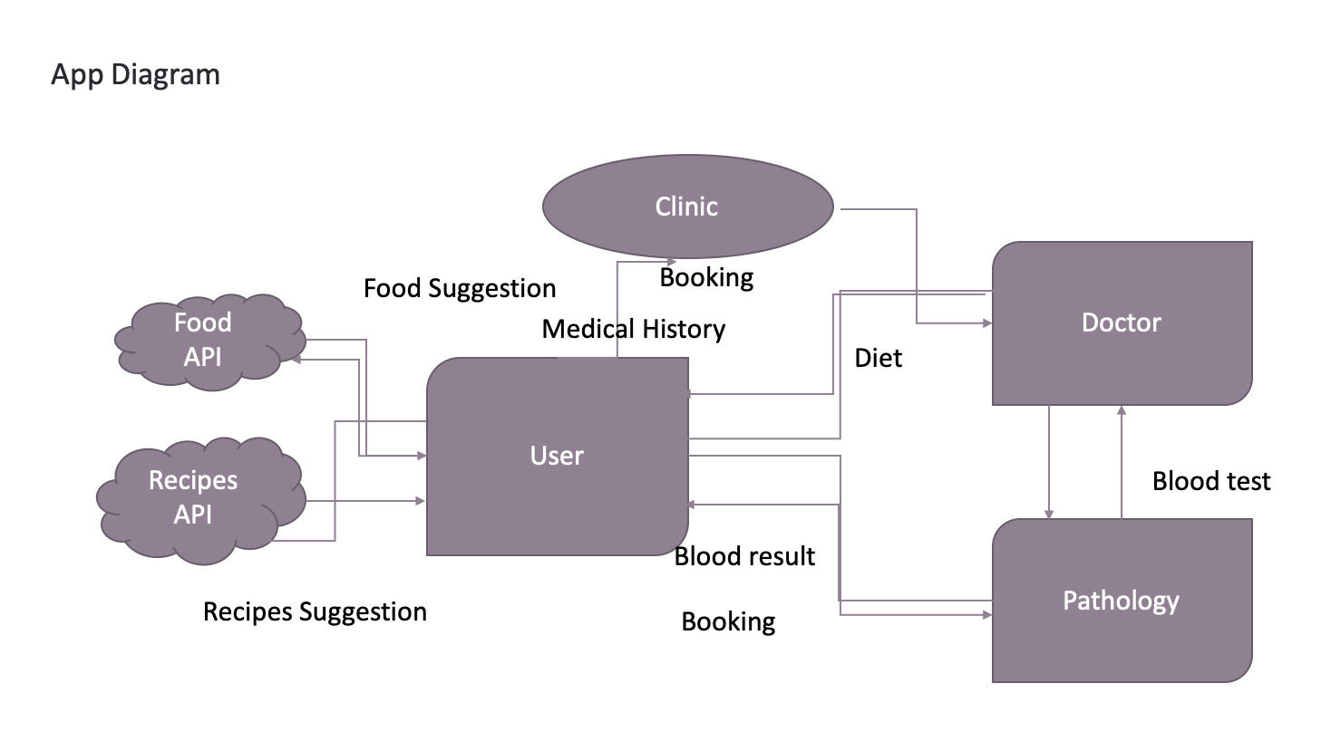
4.3 Class Diagram
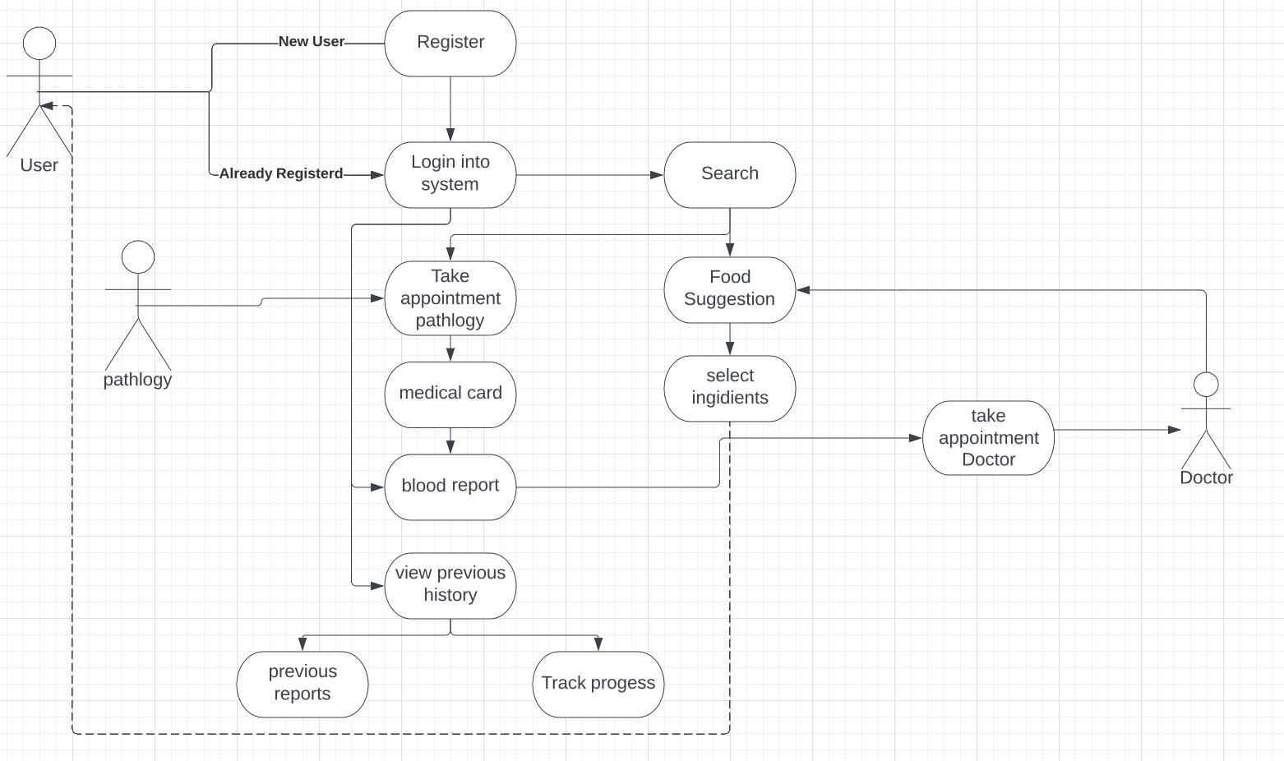

4.4 Sequence Diagram

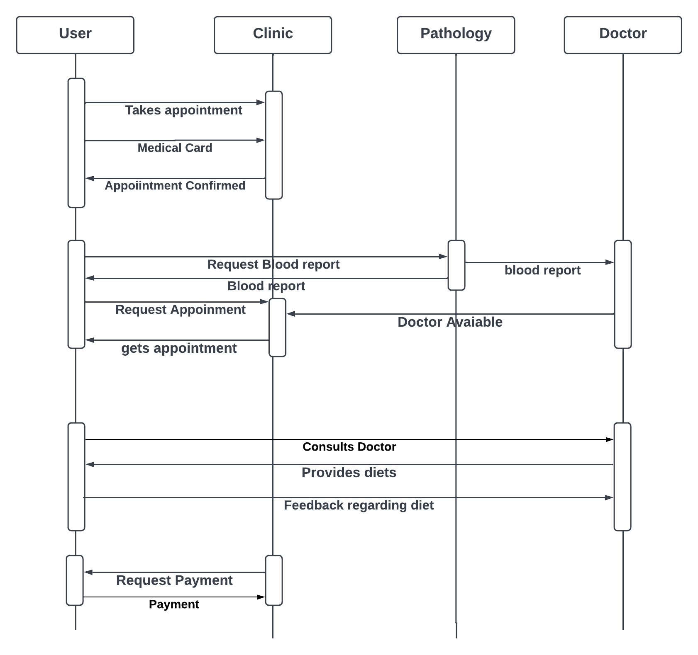

5. Other non-functional attributes

5.2 MVP

5.3 User Stories

- A login page for user with register now form if any new user for the system
- Users can see options to have general profile if they had been through a check up so they will be able check their reports or if they are new, they can book appointments with health check for pathology(blood check-up), and consult a doctor, dietician.
- There will be search bar where users can check for various doctor and dietician
- User can view their own profile and enter their desire goals
- Chatroom for patients, doctor, and dietitian to discuss their problems
- To track daily food habits users can enter their daily food intake into the system

Pathology: Suggestion for food from doctor

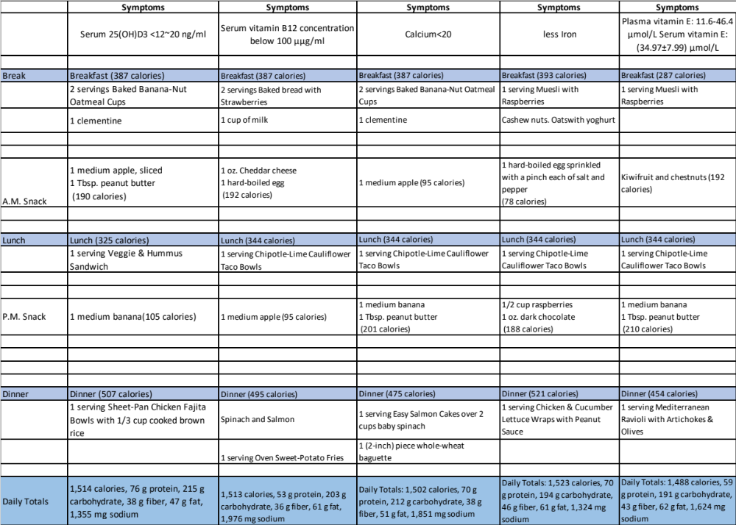

5.4 APP API

5.5 Dependencies / 5.6 Assumptions

Health First Deakin assumes that a MongoDB database of medical records will be available. The server assumes that a high speed internet connection will be installed to allow communication with the user. The software being developed assumes the user has the web version assuming the user has a computer with an internet connection and a web browser to access Health First Deakin.

The web-based version of Health First Deakin will run on the user's computer. The use of this web-based application will be entirely dependent on the availability of an internet connection.

5.7 Risks/Safety Requirements
5.7.1. Database
5.7.1.1. Data from the database will never be transmitted to unauthenticated sources
5.7.2. Application
5.7.2.1. The clinician application will never disclose patient information to users that are not authorized to see it.
5.7.3. Session App
5.7.3.1. The session app will never disclose Patient information to users that are not authorized to see it. 5.7.3.2. All patient information stored locally on the computer running the session app must be encrypted

5.8 Conclusion

The SRS document contains detailed information about the Health First Deakin requirements. The document covers the product perspective, product features, user features, constraints, any assumptions or dependencies. In section 4, the documentation gives the graphical model specifying the bridge between the user, hospital, pathology, and physician application domains. In section 5, details are given of the user story and the meal given to the user by the doctor based on the blood group test results.

5.9 Serviceability

The maintenance of the system should be able to be sufficiently performed by any person with a basic understanding of Microsoft Access.

6. Project Delivery/Operational Scenarios

Scenario A: Initial Item Definitions
The user shall enter the information about the items into the database for its initial construction and evolution. The fields will be completed via a form that will manipulate the data.

Scenario B: Customer Check for Result of Pathology
The user shall be able to enter information about the customer purchasing a particular item, and record their food and other information.

Scenario C: Database Maintenance
The user may want to alter/delete information after the auction is over, In this case they will need to be able to remove the data that has been entered.

Reference
- NHS.(2022,April).advice about food and drink. NHS choices. Retrieved January 6, 2023 from https://www.nhs.uk/medicines/warfarin/advice-about-food-and-drink/

